**Ideation Phase**

**Define the Problem Statements**

|  |  |
| --- | --- |
| Date | 19 September 2022 |
| Team ID | PNT2022TMID17812 |
| Project Name | Project – Gas Leakage monitoring & Alerting system for Industries |
| Maximum Marks | 2 Marks |

**Customer Problem Statement:**

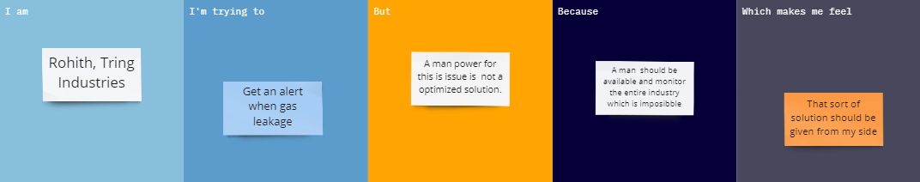

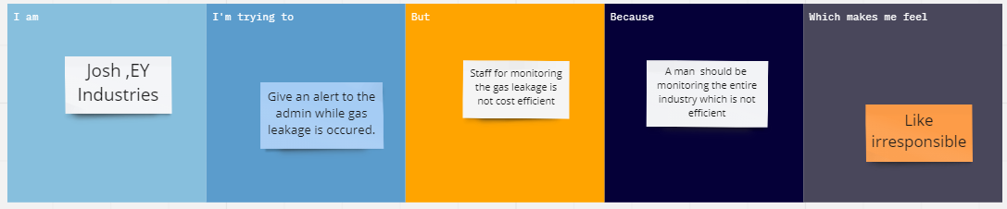

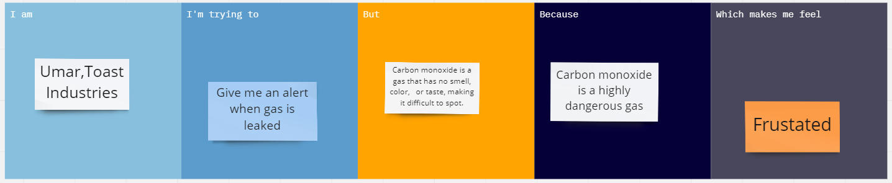

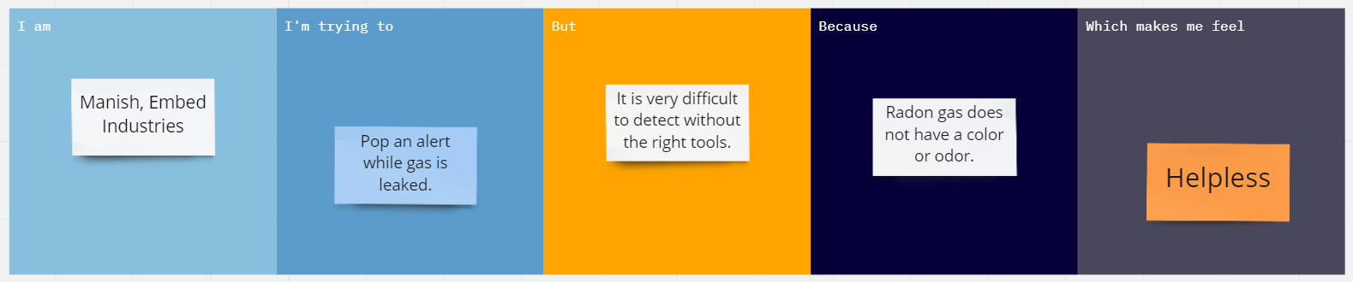

|  |  |  |  |  |  |
| --- | --- | --- | --- | --- | --- |
| **Problem Statement (PS)** | **I am (Customer)** | **I’m trying to** | **But** | **Because** | **Which makes me feel** |
| PS-1 | Rohith, Tring Industries | Get an alert when gas leakage | A man power for this is issue is  not a optimized solution. | A man  should be available and monitor the entire industry which is imposibble | A sort of solution should be given from my side |
| PS-2 | Josh, EY Industries | Give an alert to the admin while gas leakage is occured. | Staff for monitoring the gas leakage is not cost efficient | A man  should be  monitoring the entire industry which is not efficient | Like irresponsible |
| PS-3 | Umar,Toast Industries | Give me an alert when gas is leaked | Carbon monoxide is a gas that has no smell, color, or taste, making it difficult to spot. | Carbon monoxide is a highly dangerous gas | Frustated |
| PS-4 | Manish, Embed Industries | Pop an alert while gas is leaked. | It is very difficult to detect without the right tools. | Radon gas does not have a color or odor. | Helpless |